最佳结果：测试集94.0609%。RMSE:0.24395794554979822

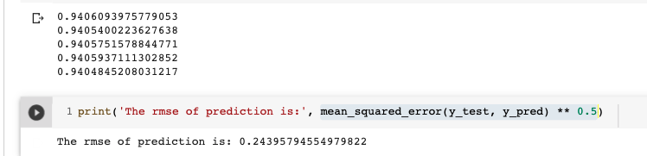

'num_leaves': 32, 'num_round': 4000, 'learning_rate': 0.0017, 'feature_fraction': 0.53, 'bagging_fraction':0.8

过程：

第一次尝试：num_leaves:32,'num_round': 1000, 'learning_rate': 0.0017, 'feature_fraction': 0.8, 'bagging_fraction': 0.8

from sklearn.model_selection import KFold

kfold = KFold(n_splits=5)

for num_leaves in [32,48,64,80,96,127]:

params = {'num_thread': 4, 'num_leaves': num_leaves, 'metric': 'binary', 'objective': 'binary',

'num_round': 1000, 'learning_rate': 0.01, 'feature_fraction': 0.8, 'bagging_fraction': 0.8}

print(params)

_,_,error_rate,_=fitter.train_k_fold(kfold, train, test, params = params)

print('%.6f%%' % ((1-np.mean(error_rate)) * 100))

{'num_thread': 4, 'num_leaves': 32, 'metric': 'binary', 'objective': 'binary', 'num_round': 1000, 'learning_rate': 0.01, 'feature_fraction': 0.8, 'bagging_fraction': 0.8}

The minimum is attained in round 733

The minimum is attained in round 565

The minimum is attained in round 581

The minimum is attained in round 613

The minimum is attained in round 539

91.898000%

{'num_thread': 4, 'num_leaves': 48, 'metric': 'binary', 'objective': 'binary', 'num_round': 1000, 'learning_rate': 0.01, 'feature_fraction': 0.8, 'bagging_fraction': 0.8}

The minimum is attained in round 633

The minimum is attained in round 494

The minimum is attained in round 620

The minimum is attained in round 530

The minimum is attained in round 524

91.864000%

{'num_thread': 4, 'num_leaves': 64, 'metric': 'binary', 'objective': 'binary', 'num_round': 1000, 'learning_rate': 0.01, 'feature_fraction': 0.8, 'bagging_fraction': 0.8}

The minimum is attained in round 748

The minimum is attained in round 489

The minimum is attained in round 552

The minimum is attained in round 539

The minimum is attained in round 465

91.820000%

{'num_thread': 4, 'num_leaves': 80, 'metric': 'binary', 'objective': 'binary', 'num_round': 1000, 'learning_rate': 0.01, 'feature_fraction': 0.8, 'bagging_fraction': 0.8}

The minimum is attained in round 681

The minimum is attained in round 499

The minimum is attained in round 498

The minimum is attained in round 454

The minimum is attained in round 465

91.814000%

{'num_thread': 4, 'num_leaves': 96, 'metric': 'binary', 'objective': 'binary', 'num_round': 1000, 'learning_rate': 0.01, 'feature_fraction': 0.8, 'bagging_fraction': 0.8}

The minimum is attained in round 720

The minimum is attained in round 498

The minimum is attained in round 460

The minimum is attained in round 447

The minimum is attained in round 473

91.750000%

{'num_thread': 4, 'num_leaves': 127, 'metric': 'binary', 'objective': 'binary', 'num_round': 1000, 'learning_rate': 0.01, 'feature_fraction': 0.8, 'bagging_fraction': 0.8}

The minimum is attained in round 573

The minimum is attained in round 461

The minimum is attained in round 505

The minimum is attained in round 463

The minimum is attained in round 482

91.730000%

最好的是91.898000%，而且是递减的

第二次尝试：round为2000

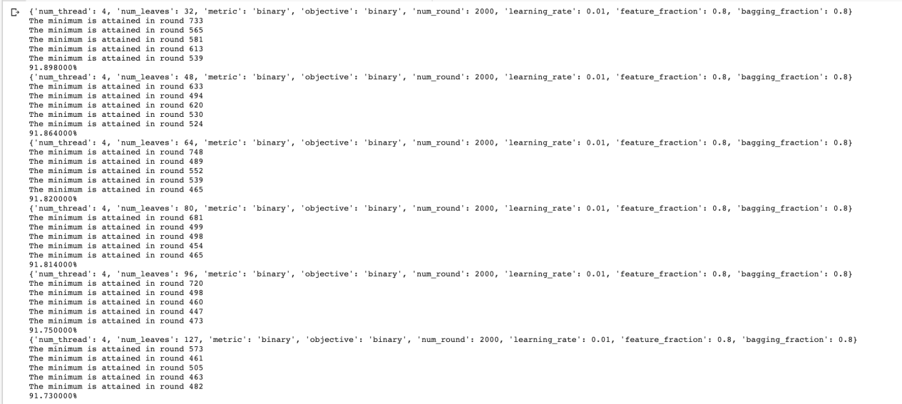

最好的是91.898000%，而且是递减的，并且round都在1000以下,说明没跑完就到最佳了，开始调整learning_rate

第三次尝试：调整learning_rate：0.005

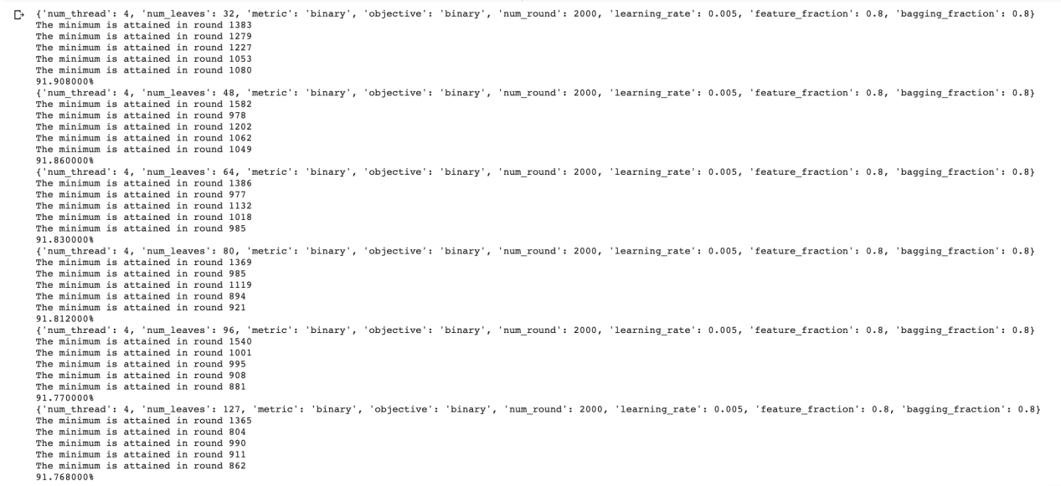

最好的是91.908000%(num_leaves:32)，后面都是递减的并且num_round都是1000以下。从num_round来看使用num_leaves:32为最佳。

第四次尝试：调整learning_rate：0.025，num_leaves只使用32



acc是91.916000%，又提升了，但round基本都到了2000，说明可能没到最佳就到round的最大值了。

第五次尝试：调整learning_rate：0.035，num_leaves只使用32



acc还是91.916000%，round下降了。下面开始尝试num_round=4000

第六次尝试：调整num_round=4000，num_leaves in [32,48,64,80,96,127]，learning_rate：0.025

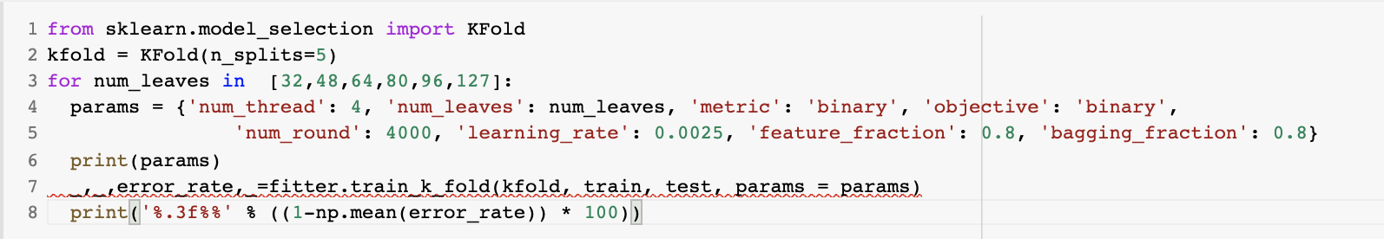

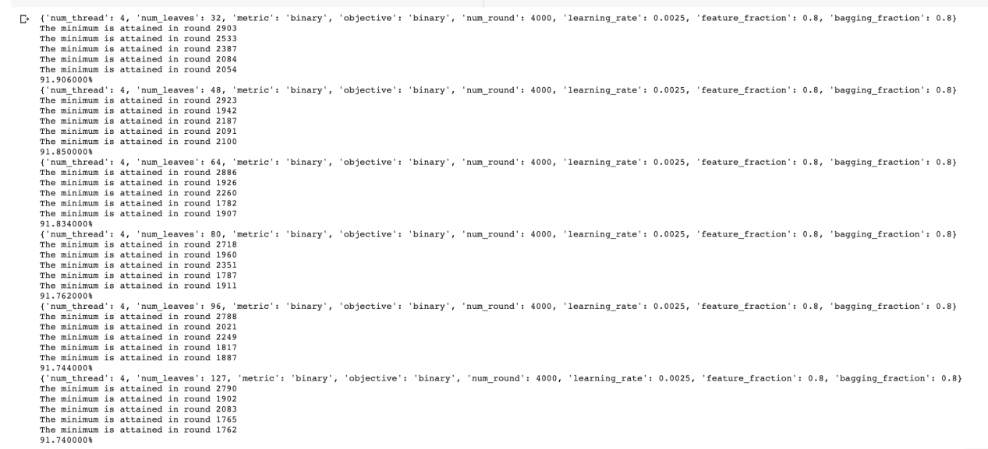

最好的是91.898000%，而且是递减的，并且round都在3000以下

第七次尝试：调整learning_rate：0.020，num_leaves只使用32



acc是91.910000%，但round还有提升空间

第八次尝试：调整learning_rate：0.015，num_leaves只使用32

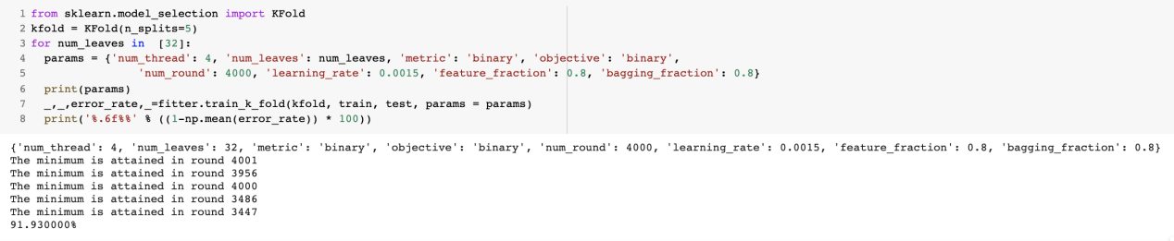

acc是91.930000%（目前最高），round都到是4000

第九次尝试：调整learning_rate：0.018，num_leaves只使用32



acc是91.914000%（目前最高），acc有下降，需要微调

第十次尝试：调整learning_rate：0.016，num_leaves只使用32



acc是91.936000%，又有提升（目前最高）

第十一次尝试：调整learning_rate：0.017，num_leaves只使用32



acc是91.94%，又有提升（目前最高）

目前确定了num_leaves:32,num_round=4000,learning_rate=0.0017。

后面开始调试feature_fraction

第十一次尝试：feature_fraction,从0.3-1.0

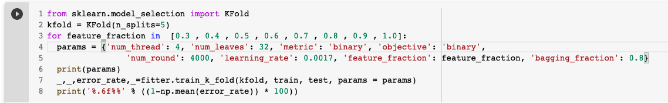

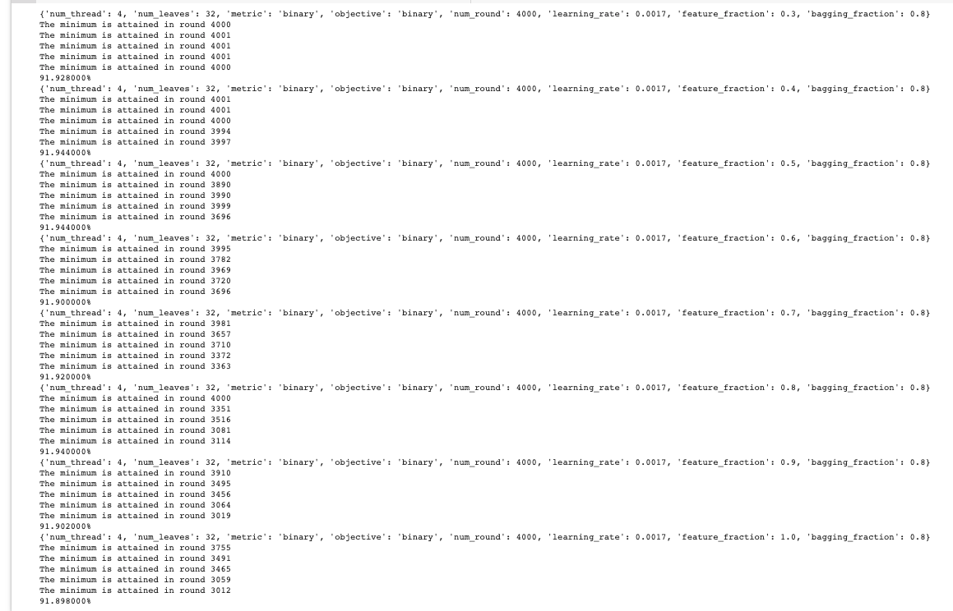

从结果看，feature_fraction=0.4和0.5的acc是91.944%是最高的（目前最高），但0.4的round有3个是靠近4000的，所以我们选择feature_fraction=0.5

第十二次尝试：feature_fraction=0.50-0.53

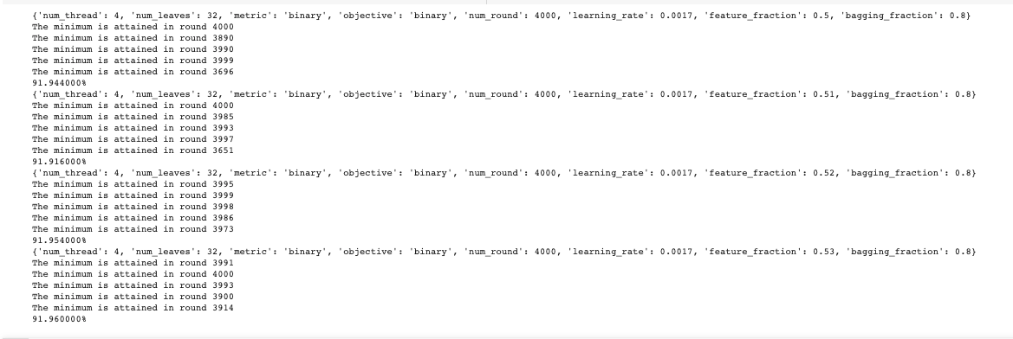

feature_fraction=0.53达到最高值91.96

第十三次尝试：feature_fraction=0.53-0.59

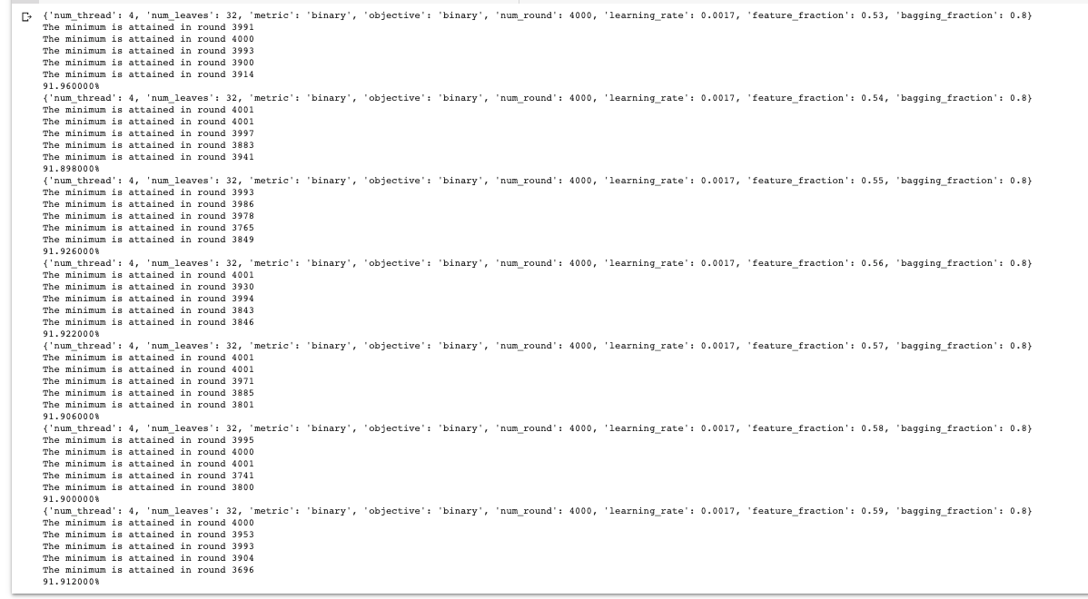

还是feature_fraction=0.53，是最高值91.96%

第十四次尝试：bagging_fraction=0.6-1.0

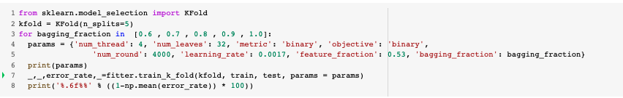

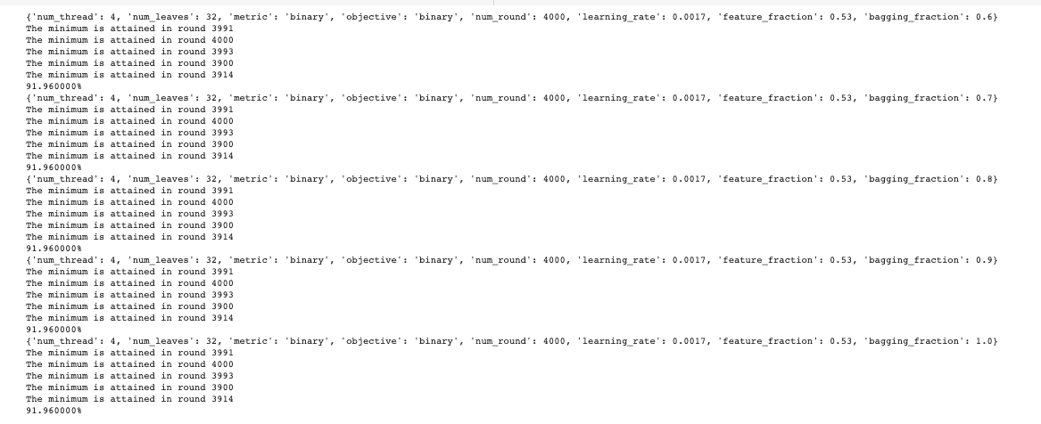

acc都一样,最终的参数 'num_leaves': 32, 'num_round': 4000, 'learning_rate': 0.0017, 'feature_fraction': 0.53, 'bagging_fraction':0.8